**PROJECTDEVELOPMENT PHASE**

**SPRINT-1 TEST CASES**

|  |  |
| --- | --- |
| Date | 08 NOVEMBER 2022 |
| TeamID | PNT2022TMID08411 |
| Project Name | Emerging methods for early detection of forest fires |
| Maximum Marks | 8Marks |

**Login Page**

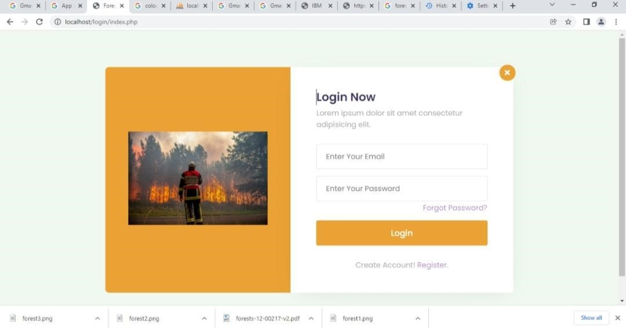

**RegisterPage**

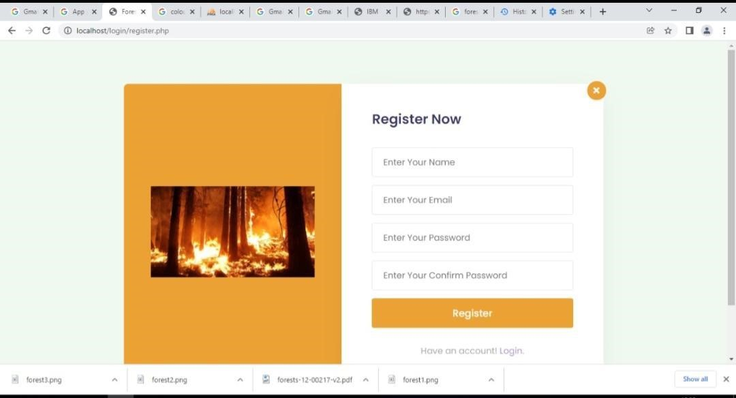

**UserConfirmation**

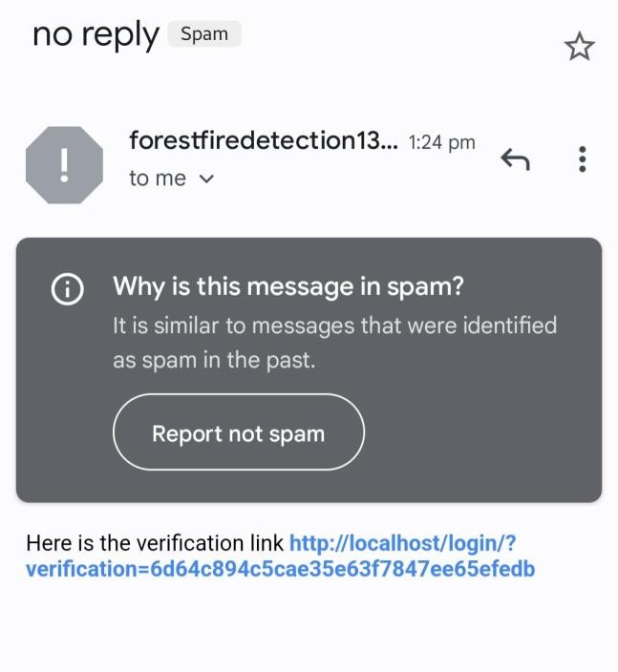

**Forget Password**

